State of Louisiana
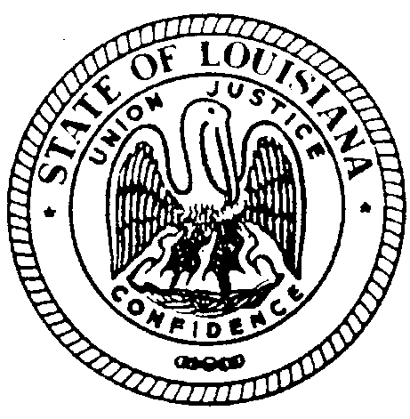
THE LOUISIANA BOARD FOR HEARING AID DEALERS

MINUTES OF MEETING
January 22, 2022
EMBASSY SUITES CONGRESS ROOM BATON ROUGE, LOUISIANA

The Louisiana Board for Hearing Aid Dealers Meeting was called to order at 1:30pm on
January 22, 2022 held at the Embassy Suites Congress Room Baton Rouge, LA by Chairman Jeremy Stroud.

Visitor(s): NONE

- CALL TO ORDER:
Those present were Kirt Loupe, Bryan Stinson, Jeremy Stroud, Emily Fonte, Cherry Collum, & Jana Broussard. Quorum established. Dina Zeevi, the Board’s Administrative Secretary was present to take the minutes of the meeting.

PUBLIC COMMENTS- NONE

- APPROVAL OF AGENDA
Emily Fonte makes a motion to accept the meeting agenda. Motion 2nd. Approved Unanimously.

- READING/APPROVAL OF MINUTES June 26, 2021
Minutes of the meeting were presented to the Board in form of an advanced email. Bryan Stinson made a motion to accept the minutes; the motion was seconded. All in favor, approved unanimously.

- Ethics Review Complaint #118 12/21 Craig Davidson, legal counsel for LABHAD explained the process of due process for the Complainant’s right to give a comment on his behalf regarding the complaint. The Complainant made a statement stating his innocence regarding the Complaint filed against him.
Kirt Loupe made a motion to move into Executive Session @ 1:47pm. Motion 2nd. Unanimously Approved. Kirt Loupe made a motion to end Executive Session and return to Regular Session @ 2:11pm. Unanimously Approved.

2:20pm Break- 10 Minutes Resumed @ 2:30pm

- SECRETARY/TREASURER’S REPORT
Presented by Emily Fonte. ’21-’22 Proposed Budget Reviewed. No issues with Report.

- Administrative Secretary Report
Presented by Dina Zeevi.
2021- 253 Request for License Verification, 32 emails for applications, 25 emails for Continuing Education information.
Reports: Monthly & Quarterly & Annual Reports completed for the State.
Licensed Hearing Aid Dealers Renewals: 94
2 TTP issued from July 2021 both dropped out
2 COE issued
No applicants for Exam
25 Corporate Forms- Non Exempt. Northland Hearing filed incomplete.

- COMMITTEE REPORTS
Ethics Committee: Kirt Loupe reviewed Complaints #116, & #117 (2), Ethics Committee recommends dismissing complaints, no statue violations found. Bryan Stinson made a motion to accept the recommendation of the Ethics Committee to dismiss the complaints #116 & #117, motion 2nd. Unanimously approved.

Examination Committee: Bryan Stinson stated 2 TTP dropped out of the program. No applications for examinations.

Legislative Committee: Jeremy Stroud stated reduction of CEs from 15 to 12 has taken effect. Telehealth Statutes will be filed to our Rules, not as statutes. Still a work in progress. Had LABHAD added to the Telehealth Access Act. Redefined statute regarding repairs and maintenance of hearing aids. Statute revision will be reworded by an attorney from the State Legislature. The LABHAD revision approved will be reworded by the attorney for the legislature.

- UNFINISHED BUSINESS
RS 37:2465 will eliminate Section A and Section B. Bryan Stinson made a motion to accept the revision. Motion 2nd. Jeremy Stroud opposed. Passed by majority vote.

- NEW BUSINESS
None

- ELECTION OF OFFICERS
Alisea Cormier will replace Kirt Loupe in District IV. All paperwork has been submitted. Motion made by Bryan Stinson to retain Jeremy Stroud as Chairman & Emily Fonte as Secretary/Treasurer. Bryan Stinson will remain Examination Committee Chair and fill the Ethics Committee Chair position. Motion 2nd. Unanimously approved.

DATE AND LOCATION OF NEXT 2022 MEETING/PRACTICAL EXAMINATION

Chairman Jeremy Stroud set next meeting/practical examination date and location:
Practical Examination DATE: Saturday June 10, 2022 TIME: TBD
Meeting DATE: Saturday June 11, 2022 TIME: TBD
Location: Metairie Marriott Lakeway

Motion made by Bryan Stinson to adjourn meeting, the motion was seconded. All in favor, approved unanimously.

Meeting adjourned at 4:05pm

